Save a Baby Kangaroo
Assessing the learning

Case Study description
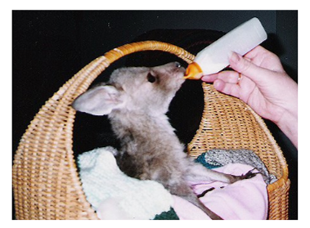
Pupils identify a feeding programme for a baby kangaroo. In the trials, most schools concluded with pupils making oral presentations of their findings.
Suitability National Curriculum levels 4 to 6. An optional assessment activity is provided which is suitable for pupils working at levels 6 to 8.
Time The assessment activities are part of the case study and can be completed within the lesson and homework time given for the case study. The optional assessment activity, which is linked to, but not part of, the case study, will be useful for pupils working at higher levels of the national curriculum; its timing is flexible.
Resources The optional assessment activity can be found on the Excel spreadsheet, Kangaroo feeding. Teachers may wish to use a whiteboard to introduce this activity.
Opportunities to assess the Key Processes
- Representing: during the optional activity
- Analysing: during lessons 1, 2, 3 to 5 and the optional activity
- Interpreting and evaluating: during lessons 1, 2 and the optional activity
- Communicating and reflecting: during lesson 3 and the optional activity
In addition to assessment of the Key Processes, there are opportunities to assess Range and Content (detail is within the case study) and some of the other personal, learning and thinking skills, particularly for ‘team working’.

Lesson 1: So what is so different about a joey?
Pupils learn about marsupial birth and development, comparing these with other animals.
Teacher guidance
Observe how well pupils:  - Use their mathematical understanding when completing the worksheet in task 1.2  - Interpret the data, comparing different animals to draw reasoned conclusions | 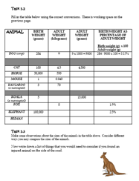  Worksheet from task 1.2
Questions to ask:
- How did you work out your answers? What accuracy did you work to and why?
- How did you find the birth / adult) weight for a fox / elephant?
- Did any of the percentages surprise you? Why? Is the table written in any special order?
- Could you group the data? How?

Assessment guidance: Progression in Key Processes

 | Analysing (i) | Analysing (ii) | Interpreting and evaluating
PROGRESSION | Uses the given method to complete the first 5 rows, mostly working accurately | Is confident in converting gms to kgs and kgs to gms | Notes simple relationships, eg ‘The marsupials have lower percentages’
 | Uses realistic figures (estimated or researched) to find a value for humans (likely to be 3 to 5%) | Rounds up where appropriate  Pupil A | Recognises distinct groups, eg marsupials and other animals
 | Uses inefficient methods, eg trial and improvement, to find solutions for fox and elephant  Pupil A | When asked, can explain why the ratio for dog should be 3.16% rather than 3.15% as shown on the worksheet | As above, and that the horse is greater than might be expected in comparison with the other mammals  Pupil A
 | Uses efficient methods to find solutions for fox and elephant | Is confident about the level of accuracy to use, and can justify decisions | As above, and categorises groups effectively, eg marsupials as less than 1% and others as 1 to 10%

Sample response: Pupil A

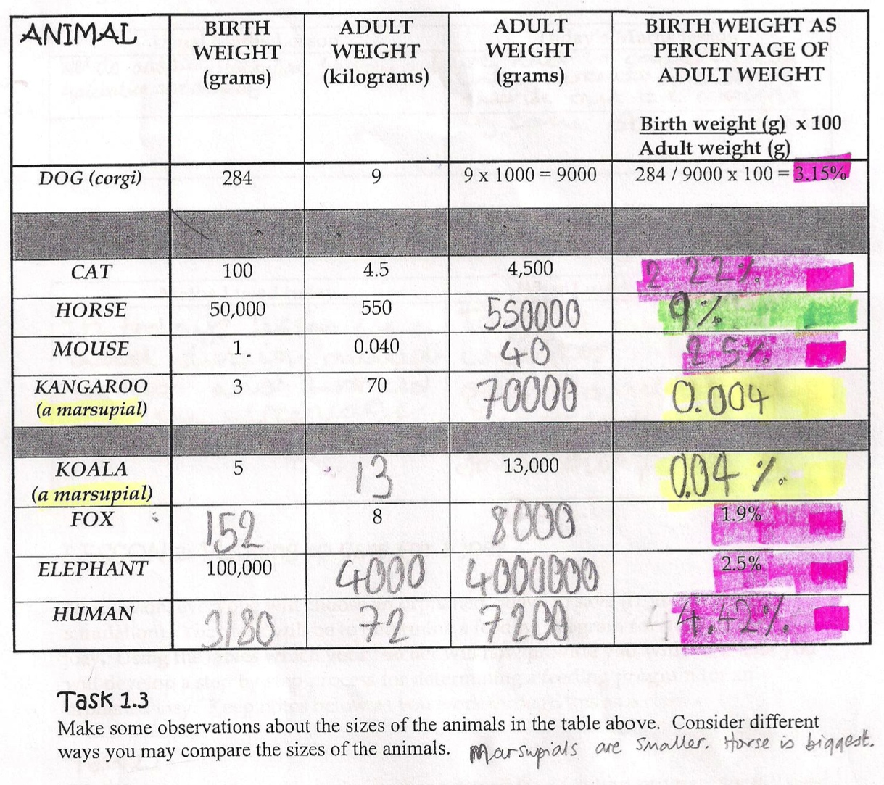

Comments

Pupil A works confidently and accurately, grouping results effectively. In discussion, she said that she used trial and improvement to find the weights of the fox and elephant.
Probing questions and feedback
- What accuracy did you decide to use and why? Why does it matter what accuracy you use?
- Why is trial and improvement not usually the best way to find a solution? Can you rearrange the equation so that birth weight is the subject?

Pupil A would benefit from working on activities in which consistent and appropriate rounding leads to effective solutions. Working with other pupils could support her understanding.

Lesson 2: Planning to care for a joey
Pupils work in groups to become ‘joey experts’ on one species.
Teacher guidance
Observe how well pupils:  - Interpret the data provided  - Make decisions about how to re-present the data  - Understand connections between the sets of data | 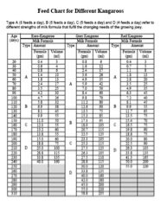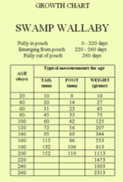  Feed and Growth Charts
Questions to ask:
- Can you explain how to use the Feed Chart? What do A, B, C and D refer to?
- How does your joey’s weight change over time?
- Would the graph of weight against age be a straight line? Why not?
- How will your graphs help you find the age of your joey?
- How will you decide how much to feed it?

Assessment guidance: Progression in Key Processes

 | Analysing | Interpreting and evaluating
PROGRESSION | Teacher support is needed, eg to use the feed charts and to find suitable scales for graphs  Pupil B | Makes simple statements, eg ‘As joeys get older, their weight increases’  Pupil B
 | Uses the feed charts and produces mostly accurate graphs with suitable scales and clearly labelled axes | Interprets the shape of the graphs, eg ‘weight doesn’t change much but then suddenly it grows a lot’
 | Recognises why graphs are a suitable means of showing changes in data over time, and produces accurate and clearly labelled graphs  Pupil C | Reflects further, eg by considering how the graphs might continue
 | Shows all three sets of data on one graph, ie an accurate double axis graph | Shows understanding of how the sets of data inter-relate  Pupil C

Sample response: Pupil B

Comments

Pupil B explained: ‘the graph shows its feet get bigger’. However, his graph showed foot size falling to zero.
Probing questions and feedback
- What does your graph show the foot length to be when the joey is 240 days? What does it show when the joey is 260 days? Why is that not possible?

Pupil B would benefit from creating and discussing a range of graphs that represent real-life situations.

Sample response: Pupil C
Comments

Pupil C drew straight lines to support his understanding of rate of change. He linked information from the feed chart to summarise how the joey grows during each feeding stage.
Probing questions and feedback
- How would you create a double-axis graph to show all three graphs on one chart? What are the advantages and disadvantages of doing that?

Pupil C would benefit from opportunities to extend his understanding of different types of graphs.

Lessons 3 to 5

During these lessons, pupils produce a poster summarising information about a species of joey. Pupils then use their poster and those produced by class mates to determine the age and species of an unknown joey. Finally, pupils summarise their findings.
Teacher guidance
Observe how well pupils:  - Use a range of information to determine the most likely species and age of the unknown joey  - Communicate the reasons for their choice  - Consider how likely their answer is to be correct | 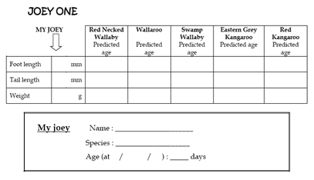  Orphaned joey card
Questions to ask:
- Which graphs/posters are most helpful? Why? What would you change about
your groups’ poster and why?
- What are the most important factors you will be looking for?
- How confident are you that the species is correct? What about its age?

Assessment guidance: Progression in Key Processes

 | Analysing | Communicating and reflecting
PROGRESSION | Takes accurate and relevant measurements for their joey | Explains what they have done and why
 | Identifies the species and age of their joey | Reviews their own or others’ work, suggesting simple means of improvement, and explaining their findings  Pupil D
 | Identifies the species and age of their joey, explaining the conclusions | Reviews their own or others’ work, suggesting means of improvement, and explaining their findings clearly
 | Identifies the species and age of their joey, explaining the conclusions and recognising that there is an element of uncertainty  Pupil D | Uses a range of forms to communicate effectively and concisely; critiques their own and others’ performance

Sample response: Pupil D

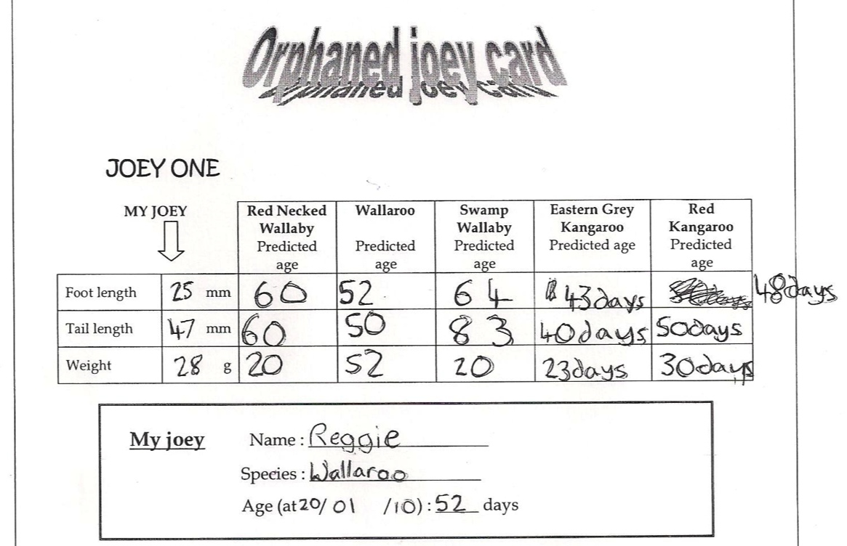

Comments

Pupil D correctly identified her joey. She played an active part in her group’s oral presentation, arguing that although tail length is shown as 50 days rather than 52 ‘things don’t grow exactly, so you can’t be certain it will be exactly that, it is just a rough idea’.
Probing questions and feedback
- Which of mean, median or mode did you use when selecting your value of 52? Why? Can you explain why you didn’t use (…)?

Pupil D would benefit from reviewing others’ work. This would allow her to compare approaches and encourage her to reflect on her own performance.

Optional Assessment Activity: Kangaroo feeding

The activity below is a demanding multi-step problem that builds on the case study. It can be used during or after the case study, in class or for homework, in groups or individually, on screen or from paper. Use of ICT allows pupils to make calculations speedily and accurately.
Pupil and teacher spreadsheets are provided with the assessment material

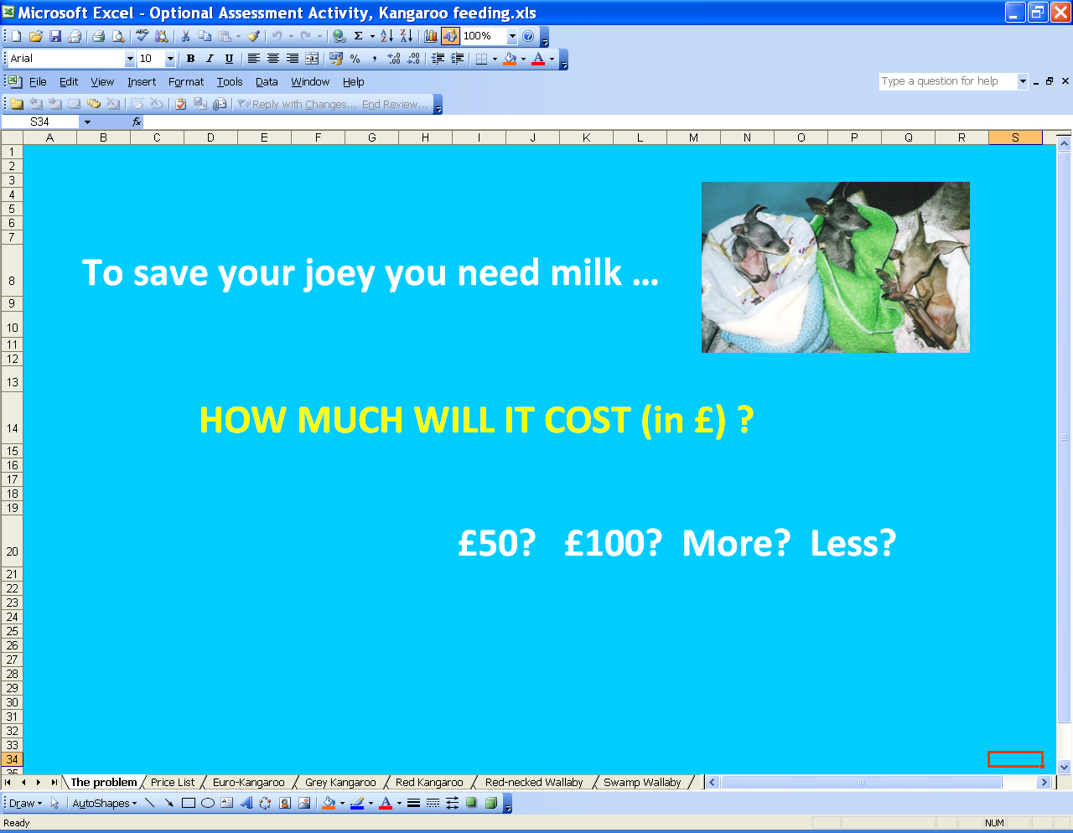
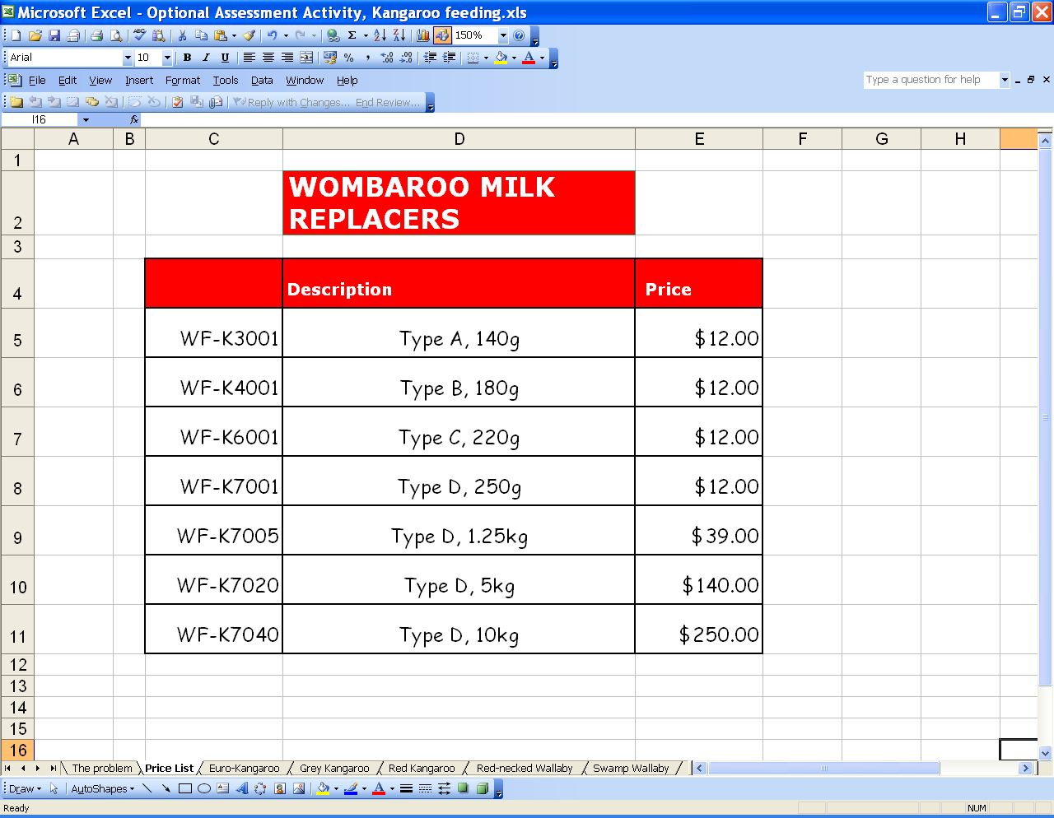
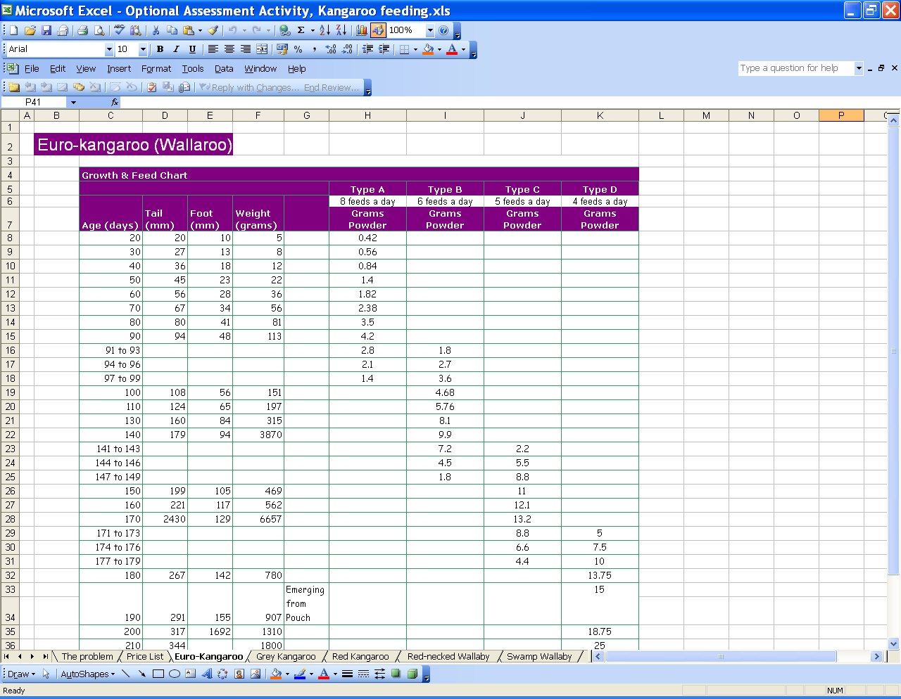

If pupils are going to save a joey they must ensure they have the correct milk and enough of it … but how much will it cost? Ask pupils to make a very rough guess … £50? £100? More? Less?

Allocate different groups of pupils a 20 day old joey of a known species; varying the species as much as possible. Tell them that they are going to work out the total cost of feeding their joey until it is fully out of the pouch.

Pupils use the given information (on the spreadsheet) to solve this multi-step problem, researching for themselves the current conversion rate from Australian dollars to English pounds.

Note that the data used is simplified from that available at http://www.wombaroo.com
Pupils may prefer to access the site directly but may need support in interpreting the data. Note that the values are presented as shown, including ‘Not valid’ for foot length for joeys of age 230 days.)

Assessment guidance: Progression in Key Processes

 | Representing | Analysing | Interpreting and evaluating | Communicating and reflecting
PROGRESSION | Needs teacher support to break down the problem | Makes simple relevant calculations | Attaches meaning to values obtained, eg ‘cost per day’ | Explains the approach in outline
 | Selects appropriate tools, eg chooses to use simple formulae | Finds the total number of grams for one day in each of the intervals | Recognises that complete bags must be bought | Shows partial methods, so that someone else can follow the reasoning
 | Recognises that age (days) refers to multiple days and chooses a method to proceed accurately | Multiplies the amount of food needed per day by the number of feeds per day | Notes assumptions, and searches for the cheapest solution  Pupil pair E | Gives a clear explanation of methods and findings
 | Chooses methods that enables the problem to be solved efficiently and concisely  Pupil pair E | Gives a clear, comprehensive and accurate solution  Pupil pair E | As above, and recognises that the solution is a ‘best fit’ given the information provided and assumptions made | Uses a range of forms to communicate findings effectively and concisely  Pupil pair E

Sample response: Pupil pair E

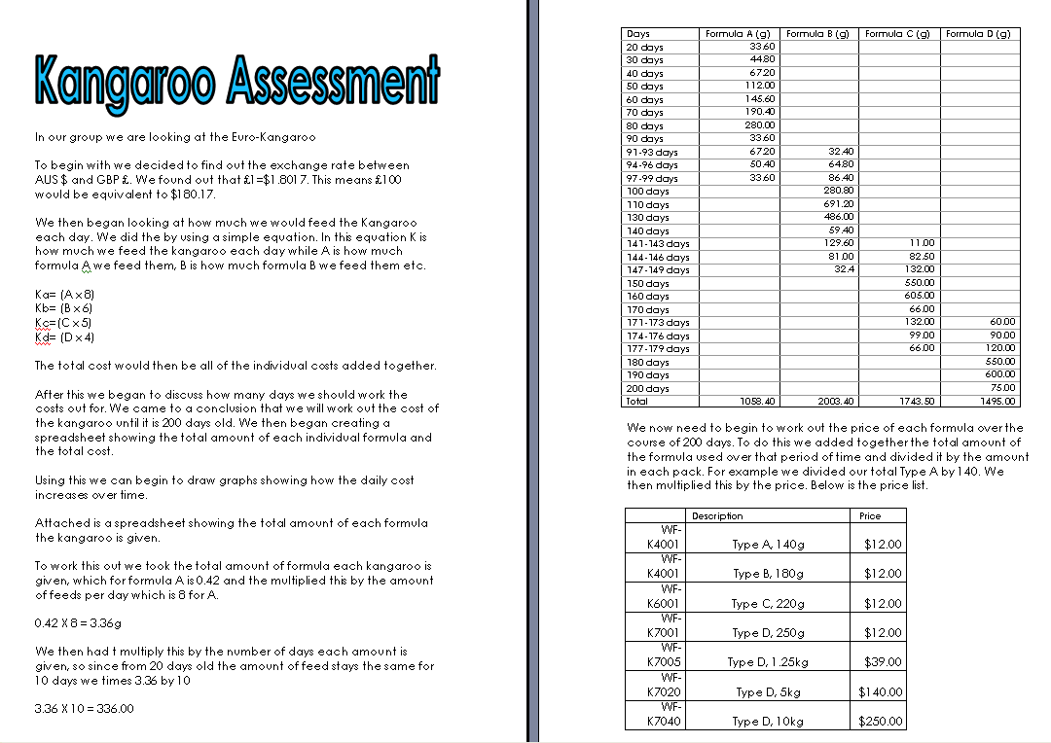

Comments

The pupils provided a comprehensive report stating assumptions and showing relevant calculations.
Probing questions and feedback
- How confident are you that the cost will be exactly £214.80?

The pupils would benefit from working on other multi-step problems, using a wide range of mathematical techniques.

