Outbreak

Assessing the learning

Case Study description
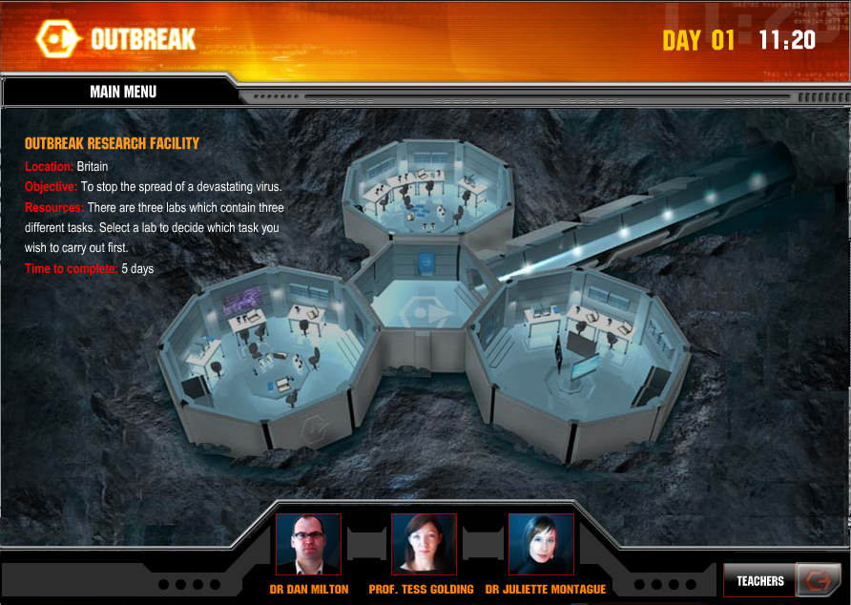
Pupils work to contain the spread of a deadly disease.
Suitability National Curriculum levels 4 to 8
Time The assessment activities are part of the Case Study and can be done within the time for it.
An optional assessment activity (page 8) is linked to, but not part of, the case study; it could be used to challenge able pupils during the initial phases of the Case Study. It could be undertaken for homework.
Resources All activities are based on materials already within the Case Study.

Opportunities to assess Key Processes
- Representing: during lessons 1, 2, 3 and the optional activity
- Analysing: during lessons 2, 3 and the optional activity
- Interpreting and evaluating: during lessons 1, 2, 3 and the optional activity
- Communicating and reflecting: during lesson 3 and the optional activity
In addition to assessment of the Key Processes, there are opportunities to assess Range and Content (detail is given in the Case Study) and some of the other personal, learning and thinking skills, particularly for ‘team working’.
In trials, pupils presented their findings, providing further opportunities to assess Process Skills.

Lab 01: Infection Detection
Pupils analyse and interpret information to identify the location of infected people.
Teacher guidance
Option 1 offers the greatest opportunities for assessing the Key Processes.
Observe how well pupils:  - Develop a strategy  - Work logically | 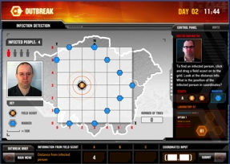  Option 1: Identifying the location of infected people
Questions to ask:
- How did you decide where to place your first scout?
- What did you do next?
- What strategies did you use to become more efficient?

Assessment guidance: Progression in Key Processes

 | Representing | Interpreting and evaluating
PROGRESSION | Places the scouts randomly on the grid | Using two scouts, identifies different possible locations for the infected person
 | Develops a simple strategy, eg identifies alternatives when positioning a scout and considers implications  Pupil A | Explains a strategy  Pupil A
 | Develops a strategy, eg places the first scout in a corner so that markers can be positioned quickly | Explains a strategy and considers its efficiency
 | Develops an efficient strategy, eg places the first scout in a corner, then places the second scout in such a way that it is not equi-distant from any markers  Pupil B | Explains an efficient strategy and uses mathematical reasoning to justify its efficiency  Pupil B

Sample response: Pupil A
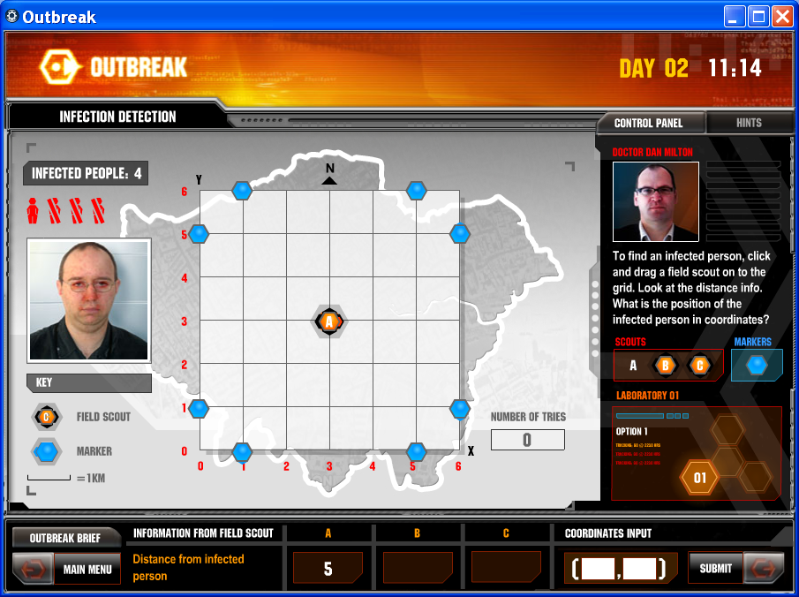

Comments

Pupil A’s strategy was to place his first scout in the centre of the grid. He explained this enabled him to use symmetry when placing markers and to ensure that the infected person is never more than 6 units away. However, he placed the second scout at random.
Probing questions and feedback
- Using the diagram shown here, can you explain why it would be more sensible to place the second scout at (0, 2) rather than at (0, 3)?
- Where else would it not be sensible to place the second scout, and why?

Pupil A would benefit from comparing his strategy with others, discussing which are most efficient and why

Sample response: Pupil B
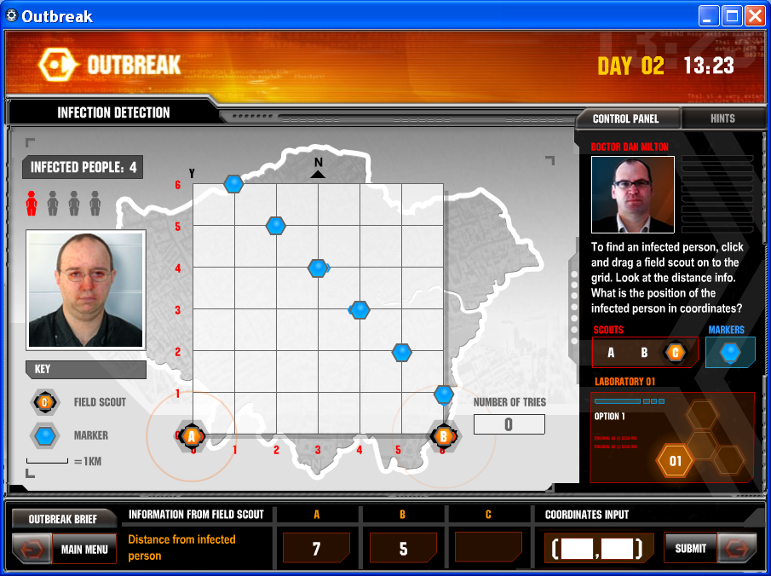
Comments

Pupil B decided on an efficient strategy to place her first scout.
In discussion, she confirmed that the choice of corner for the second scout matters since ‘if you place it diagonally opposite it’s the same distance to two places, but for the other corners each marker is always a different distance away so you can find the infected person’.
Probing questions and feedback
- Does your strategy always allow you to find an infected person using just two scouts? Why not?
- Can you work out the probability of finding an infected person using just two scouts?

Pupil B would benefit from working on complex tasks that require efficient and effective strategies.

Lab 02: Super Antidote

Pupils look for the best combination of ingredients for an antidote

Teacher guidance

The best opportunities for assessing Key Processes are in the homework options in which pupils devise their own clues to produce an antidote (see the supporting worksheets in the detailed teacher’s resource).

Before starting, pupils could discuss and agree what would make a good set of clues. Completed work can then be exchanged and evaluated against the agreed success criteria.
Observe how well pupils:  - Write relevant clues  - Write a coherent set of clues for the production of an antidote  - Review other pupils’ solutions and make suggestions for improvement | 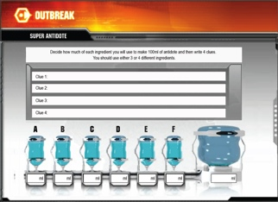  Homework option (could be undertaken in class) Design your own antidote
Questions to ask:
- Are all your clues needed to find the antidote? Are any not necessary?
- What would make your clues easier / more challenging?
- How would you evaluate your clues against the agreed success criteria?

Assessment guidance: Progression in Key Processes

 | Representing | Analysing | Interpreting and evaluating
PROGRESSION | Uses only limited mathematical content eg fractions or simple operations | Mostly creates and answers simple clues correctly  Pupil C | Gives accurate feedback to others, even if simple  Pupil C, Pupil D
 | Uses a range of mathematical content, even if based on work already seen  Pupil C, Pupil D | Creates and answers clues correctly, using a range of mathematical content  Pupil D | Gives accurate feedback, making helpful suggestions for improvement
 | Selects other areas of mathematics when creating own clues, eg uses algebra | Creates and answers clues correctly, using a wide range of mathematical content | Shows insight as to why some solutions are ‘better’ than others
 | Creates relevant, varied and demanding clues | Creates and answers demanding clues correctly, using a wide range of mathematical content | Reviews effectively, and supports the understanding of others
Sample response: Pupil C

Comments

Pupil C used percentages and simple fractions. Her review and feedback to others showed that she could create and answer simple clues but that she consistently confused volumes and percentages.
Probing questions and feedback
- What does 100% mean? How does that help you to see that your percentages must be wrong?

Pupil C would benefit from working on tasks based on real-life contexts. This would help her when reviewing her findings to check that they make sense within the context.

Sample response: Pupil D

Comments

Pupil D solved this simple problem using percentages and ratio. When reviewing others’ work, he answered more demanding clues correctly, though his feedback to them was limited to identifying errors.
Probing questions and feedback
- Think about how you have presented your clues. Why might some people find your clues a little confusing? How could you make them clearer?

Pupil D would benefit from class discussion of work from a range of pupils. This would support him in identifying strengths and weaknesses within his and others’ work.

Lab 03: Strategic Planning
Pupils decide how to allocate vaccines to different subgroups of the population.
Teacher guidance
In trials, pupils also presented their findings as this provided further opportunities to assess Process Skills.
Observe how well pupils:  - Use a spreadsheet  - Optimise their solution  - Justify their answers | 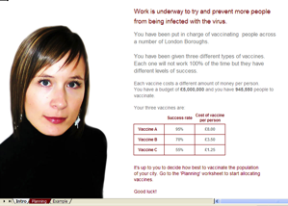  Spreadsheet Activity: Allocating vaccines
Questions to ask:
- How did you decide the number of people in each category to be given the vaccines?
- How did you use the spreadsheet? What formulae did you use and how?
- What are the likely consequences of the decisions you’ve made?
- How would you present your decisions? Why?

Assessment guidance: Progression in Key Processes

 | Representing | Analysing | Interpreting and evaluating | Communicating and reflecting
PROGRESSION | Varies values when trying to find a solution | Needs support to enter and interpret formulae | Checks then improves values | Writes or talks about findings; thinks of simple ways to improve performance
 | Varies values systematically when trying to find a solution | Enters and interprets some formulae without support | Explores the effects of varying spreadsheet entries | Communicates clearly and effectively; identifies improvements
 | Chooses an effective strategy, eg uses proportions when varying values  Pupil pair E | Enters and interprets formulae without support | Explores in a structured manner the effects of varying spreadsheet entries  Pupil pair E | Communicates clearly and effectively and reflects on efficiency  Pupil pair E
 | Chooses an effective and efficient strategy | Enters and interprets formulae efficiently and effectively  Pupil pair E | Justifies own solution as optimal | Reports and justifies findings clearly and effectively

Sample response : Pupil pair E

Comments

The pupils worked efficiently and effectively. They explained and improved their strategy and reflected on their work.
Probing questions and feedback
- What would have been the advantages of drawing a graph?
- If you were starting the task again, what strategy would you adopt and why?

Pupil pair E would benefit from discussing with other pupils the pros and cons of a range of strategies and solutions. This should help them in thinking about optional solutions when they engage with other tasks.

Optional activity: How many locations?
To provide further assessments for Process Skills, this activity builds on the work done in Lab 01: Infection Detection.

What do these hexagonal points have in common?
How many points are 3km from the centre of the grid – going along the grid lines? How many are 2km away? … 4km away? Can you find a pattern in your results?
Try to explain why the pattern occurs and predict what would happen for other distances.
Extension activity: In total, how many points are 3km or less away from the centre of the grid?
Or 2km or less away? … Or 4km or less away ….. ?
Can you find and justify a general rule?
How many locations?
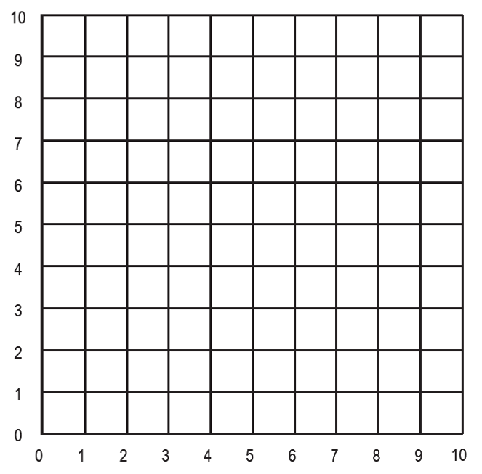

Assessment guidance: Progression in Key Processes

 | Representing | Analysing | Interpreting and evaluating | Communicating and reflecting
PROGRESSION | Uses diagrams effectively | Works systematically | Makes a prediction based on results | Writes or talks about findings; communicates clearly
 | Sets out work clearly, eg uses a table of results | Draws together results, noting term-to-term patterns | Makes and tests a prediction based on results | Draws accurate and useful conclusions
 | Uses diagrams, words and symbols | Draws together results, noting simple position-to-term relationships, even if expressed in words | Seeks to justify results  Pupil F | Draws accurate and useful conclusions, reflecting on other approaches
 | Uses diagrams, words and symbols effectively  Pupil F | Draws together results, noting position-to-term relationships  Pupil F | Shows mathematical insight by justifying findings | As above and notes connections to other work, eg recognises similar structures  Pupil F

Sample response: Pupil F

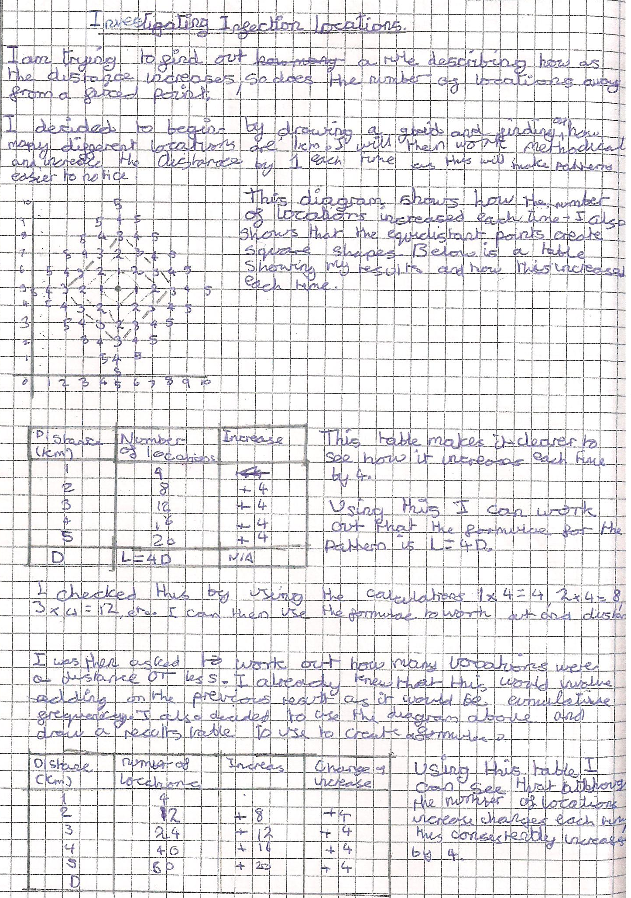

Comments

Pupil F used his mathematical understanding to find algebraic formulae that describe both scenarios.
Probing questions
and feedback

- Now that you
have found the
formulae, can you
see a way in
which you could
have used the
structure of the
problem to get to
the solution in a
different way?

Pupil F would benefit from using structure to establish generality since this will support him when justifying his findings.

