 | Lottery

Task description

Pupils decide whether or not a lottery will be a good way to raise money.

Suitability National Curriculum levels 5 to 6

Time 20 to 40 minutes

Resources Pencil and paper

Key Processes involved

- Representing: Select a method for organising the work and for determining whether or not the lottery will raise money.
- Analysing: Work logically, systematically listing the number of ways two numbers may be chosen from six.
- Interpreting and evaluating: Form a convincing argument based on their findings and deduce whether the lottery is or is not a good money raiser.
- Communicating and reflecting: Communicate their reasoning clearly and effectively.

Teacher guidance

Check that pupils fully understand the task context before they begin, perhaps by conducting a simulation of the problem as follows:

Ask each pupil to write down two numbers between 1 and 6 and then draw out two balls from a bag containing the numbers 1 to 6. The pupils who have chosen the correct pair win the game. Ask others which two numbers they chose, so that pupils realise that there are many different possible pairs of numbers. You only need to do this once or twice until they get the idea.

Pupils can tackle this task in different ways, but they might be expected to:

- Find and justify probabilities and approximations to them by selecting and using methods based on equally likely outcomes.
- Understand that different outcomes may result from repeating an experiment

Lottery

Karl is thinking of holding a mini lottery to raise money.

I will sell tickets like this for £1 each.  Each player must put a cross through 2 different numbers on the ticket and hand it in. At the end of the week I will draw out two balls from a bag.  Every player who has chosen the same two numbers as shown on the balls will win a cash prize of £10. | 

- How many ways can you chose two different numbers on the ticket?
Show all your working.
- Will Karl’s lottery be a good way to raise money?
Explain your reasons.

Assessment guidance

Progression in Key Processes

Representing | Analysing | Interpreting and evaluating | Communicating and reflecting
Choice of method for organising the work | Generating results i.e. possible pairs of numbers, and the quality of reasoning | Conclusions drawn and reasons given | Clarity and completeness of description of reasoning and how well this relates to the analysis
Selects a method for organising the work but not for determining whether or not the lottery will raise money.  PROGRE  S  S  I  ON  Pupil A | Writes down just a few pairs of numbers that may be chosen, missing most combinations.  Reasoning maybe incorrect.  Pupil A | Decides whether or not the lottery is a good money raiser but the reasons are not given or are incorrect.  Pupil A | Does not communicate reasoning, or communicates reasoning that is unclear, and/or unrelated to the analysis.  Pupil A
Selects a method for organising the work but not for determining whether or not the lottery will raise money.  Pupil B | Lists most pairs of numbers but omit some pairs or includes impossible pairs such as 2,2 or 7,4. | Decides whether or not the lottery is a good money raiser but the reasons given are incorrect.  Pupil B | Communicates reasoning clearly but it is unrelated to the analysis.  Pupil B
Selects a method for organising the work and a suitable method for determining whether or not the lottery will raise money.  Pupil C | Systematically lists the number of ways two numbers may be chosen from six.  Reasoning is mainly correct.  Pupils B and C | Includes some correct work towards determining whether or not the lottery is a good money raiser.  Pupil C | Communicates some correct reasoning effectively, relating this to the analysis, but this may be incomplete or contain errors.  Pupils C and D
Selects a method for organising the work and a suitable method for determining whether or not the lottery will raise money.  Pupil D | Systematically lists all the different ways two numbers may be chosen from six.  Reasoning is complete and consistent.  Pupil D | Decides correctly whether or not the lottery is a good money raiser.  Pupil D | Communicates their reasoning effectively, completely and correctly.

Sample responses

Pupil A

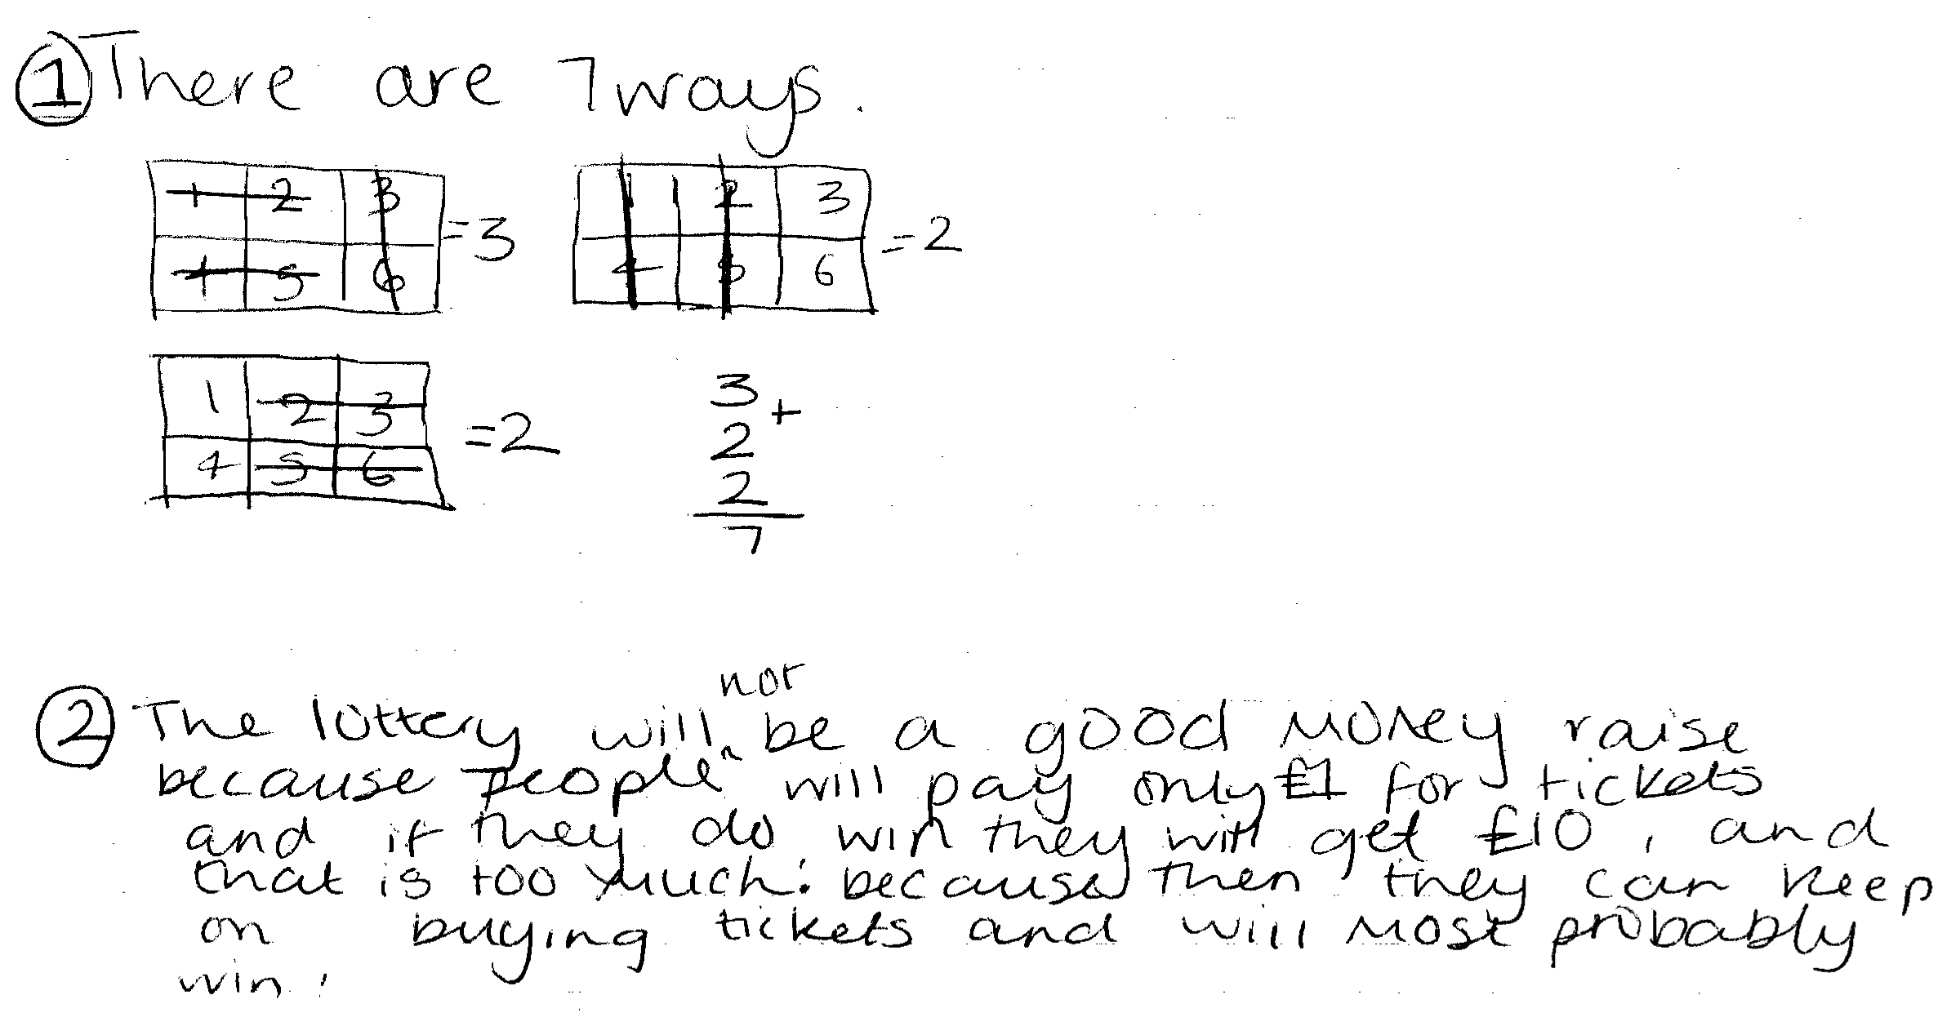

Comments

Pupil A correctly identifies 7 of the 15 possible ways of choosing two different numbers on the ticket, but his reasons for stating that the lottery is not a good money raiser are unrelated to this work.

Probing questions and feedback

- How do you know that you have found all possible number pairs? Can you find any more? Can you find them using a systematic method?
- Can you see how your list of possible pairs can help you decide whether or not the lottery will be good money raiser?

Pupil B

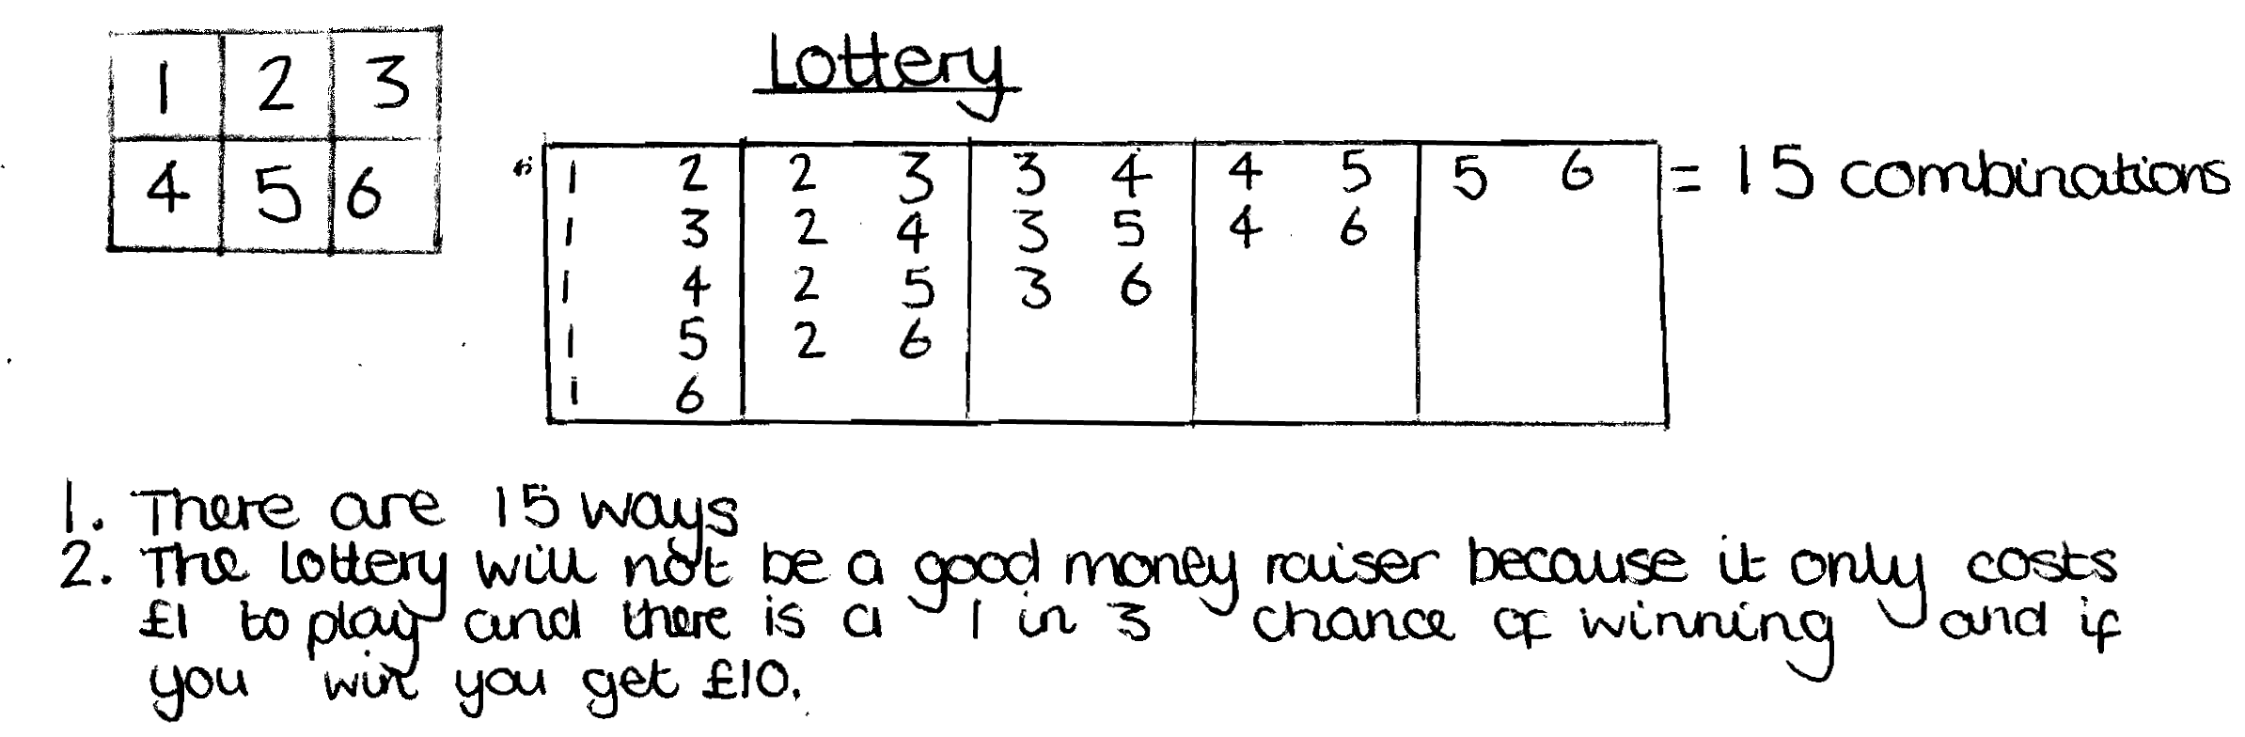

Comments

Pupil B has made substantial progress with the first part of the task, as she correctly lists all the 15 possible ways of choosing two different numbers on the ticket.
Pupil B does not make any connection between this work and her subsequent reasoning, which assumes that because two numbers are chosen from six then there is a “1 in 3” chance of winning.

Probing questions and feedback

- Can you explain why you think there is a 1 in 3 chance of winning?
- Can you see how your list of possible pairs can help you decide whether or not the lottery will be good money raiser?
- What do you think is likely to happen if 300 players play the lottery?
- What would be the most likely number of winners?
- How much money would then be raised or lost?

Pupil C
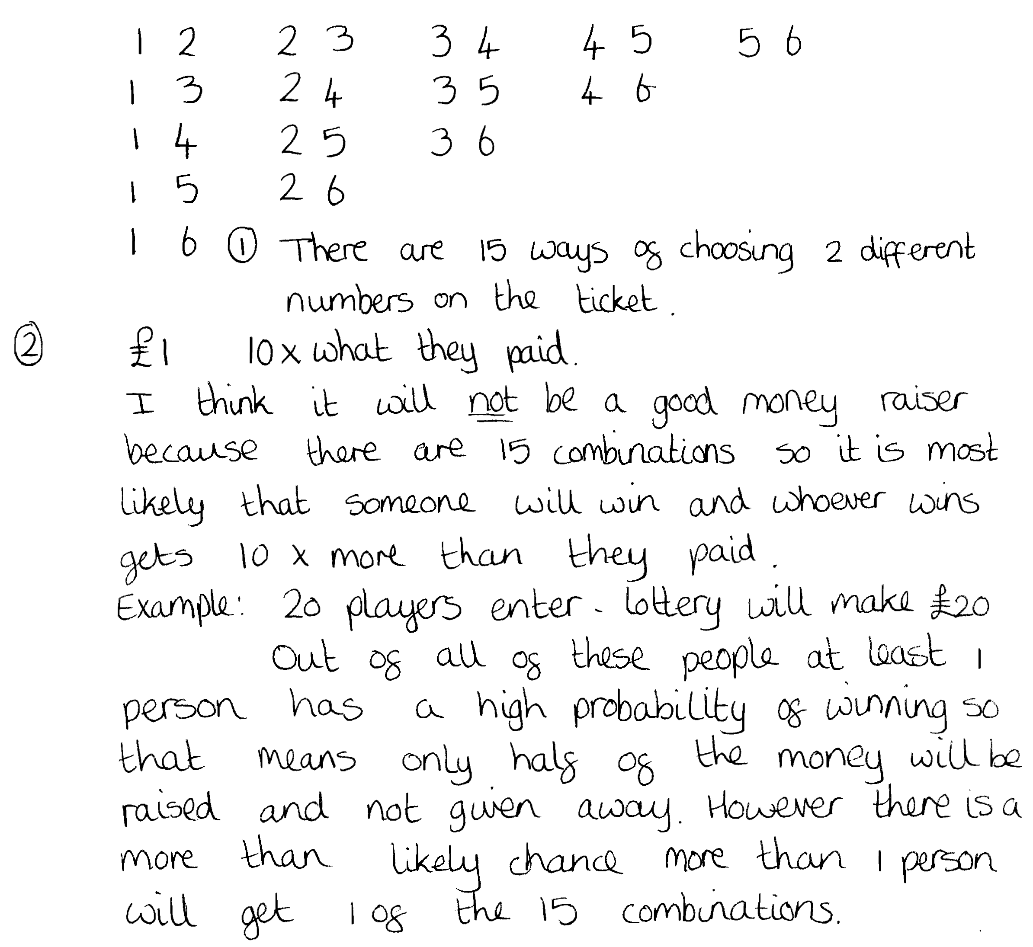

Comments

Pupil C systematically lists all 15 possible ways of choosing two different numbers on the ticket. Her reasons for stating that it is not a good way to raise money are incomplete.

Probing questions and feedback

- What do you think is likely to happen if 300 players play the lottery?
- What would be the most likely number of winners?
- How much money would then be raised or lost?

Pupil D

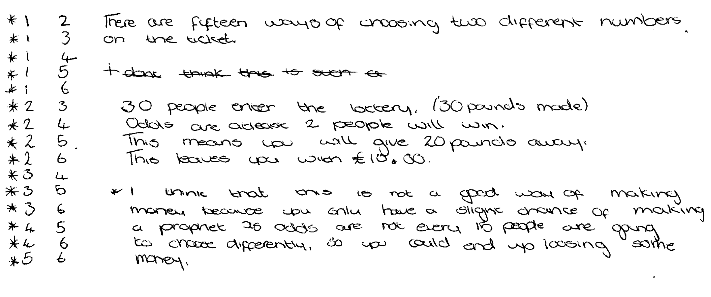
Comments

Pupil D correctly lists all of the 15 possible ways of choosing two different numbers on the ticket. His reasons for stating that it is not a good way to raise money are well argued and the work is clear and easy to follow.

Probing questions and feedback

- Would you be more sure of making a profit if more people played the lottery?
Can you explain why?
- Can you suggest ways in which the lottery could be made a better money raiser?
- What would be the effect if you increased the number of balls in the bag by one?
- What would be the effect if you asked people to choose three numbers instead of two?

